MSD Hazard Identification Tool:

Job/Task Information
Job title or task:
Date completed:
General observations:
MSD HAZARDS - GRIPPING Check [✔]
if required
Pinch Gripping  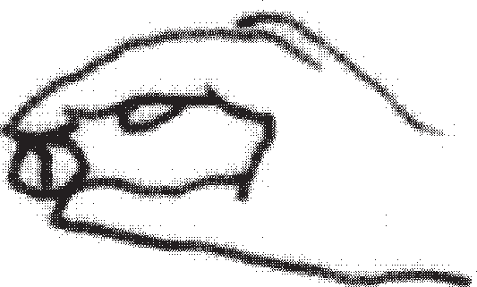 | - unsupported object(s) | ■
 | - difficult/tiring holding or manipulating | ■
 | - difficult/tiring squeezing to open/close | ■
Power Gripping  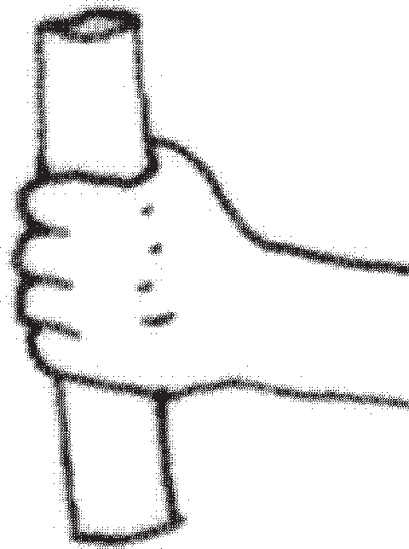 | - unsupported heavy object(s) | ■
 | - difficult/tiring holding and manipulating | ■
 | - difficult/tiring squeezing to open/close | ■
 | Notes:
MSD HAZARDS - FORCE Check [✔]
if required
Lifting/Lowering  (consider both one and two handed  lifting/lowering) | - object is heavy/difficult to lift/lower | ■
 | - object is lifted/lowered repeatedly | ■
 | - object is above the shoulders | ■
 | - object is below the knees | ■
 | - object is far away from the belly button | ■
 | - loads are unstable, unbalanced, uncooperative, or unpredictable | ■
 | - lifting/lowering postures are awkward (bend, twist, kneel, reach, sit) | ■
 | Notes:
Pushing/Pulling  (consider one and two handed pushing/pulling. Also, consider whole body & arms/upper body only pushing/pulling) | - object is hard/difficult to push/pull | ■
 | - object is pushed/pulled repeatedly | ■
 | - object is pushed with hands above the shoulders | ■
 | - object is pushed with hands below the waist | ■
 | - pushing/pulling postures are awkward (bend, twist, kneel, reach, sit) | ■
 | Notes:

MSD HAZARDS - AWKWARD/FIXED POSTURE Check [✔]
(Do workers frequently assume these postures and/or hold them for a long time?) if present
Awkward Posture  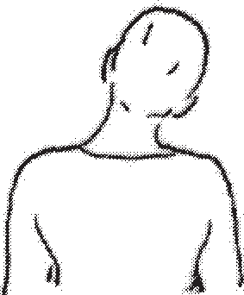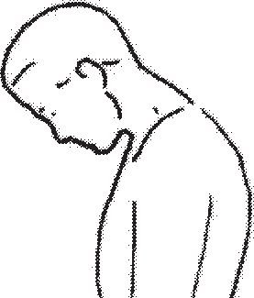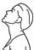  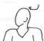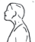 | - neck visibly bent forward (chin close to chest) | ■
 | - neck visibly bent to one side (ear close to shoulder) | ■
 | - neck twisted to either side/chin close to the shoulder | ■
 | - neck noticeably bent back | ■
 | - neck bent forward and chin out (head forward) | ■
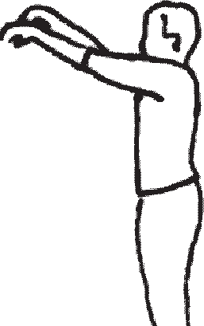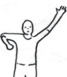 | - hand(s) at or above the head | ■
 | - elbow(s) at/or above the shoulder | ■
 | - elbows/hands behind the body | ■
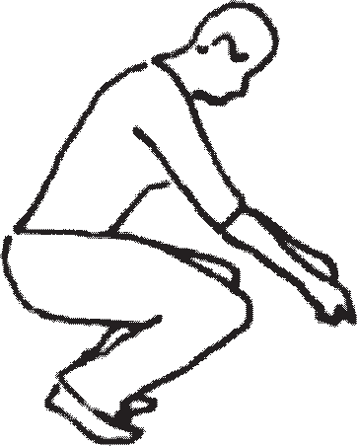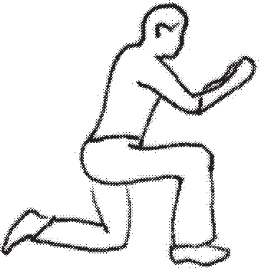 | - sitting or standing with the back noticeably bent forward, sideways, or twisted | ■
 | - back noticeably bent backward with no support for the back | ■
 | - squatting/kneeling while working | ■
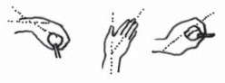 | - wrist noticeably bent down or up | ■
 | - wrist noticeably bent to the side (toward thumb/little finger) | ■
 | - hand turned so palm faces fully up or down | ■
Fixed Posture | - sitting for long periods without standing (office work, driving, etc.) | ■
 | - standing still on a hard surface for a long period of time | ■
MSD HAZARDS - REPETITION Check [✔]
(Do workers repetitively move the same body part – with little opportunity for recovery?) if present
Repetition | - performing the same neck motions repeatedly | ■
 | - performing the same shoulder motions repeatedly | ■
 | - performing the same elbow motions repeatedly | ■
 | - performing the same wrist motions repeatedly | ■
 | - performing the same hand/finger motions repeatedly | ■
 | - performing intensive keyboarding | ■
 | - performing intensive mousing | ■
MSD HAZARDS - OTHER Check [✔]
if present
Repeated Impacts | - using the hand or knee as a hammer | ■
Contact Stress | - tool handles dig into hand/palm | ■
 | - workstation/equipment edges/products dig into body (hands, forearms, trunk, thighs) | ■
Hand-Arm Vibration | - using vibrating tools (impact wrenches, carpet strippers, chainsaws, jackhammers, scalers, riveting hammers, grinders, sanders, jig saws, jack-leg drills.) | ■
Whole-Body Vibration | - operating mobile equipment/vehicles on rough, uneven surfaces | ■
Cold/Hot Temperatures | - work environment is cold, hand/arms are exposed to cold air | ■
 | - work environment is hot/humid | ■

