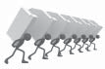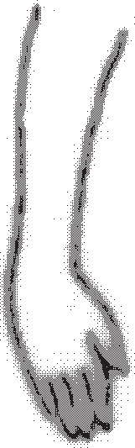**MSD Hazard Identification Tool**:

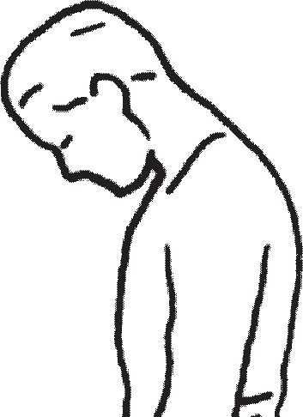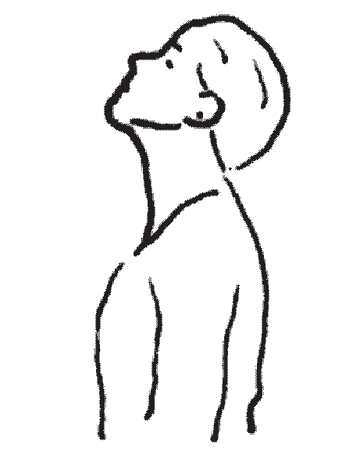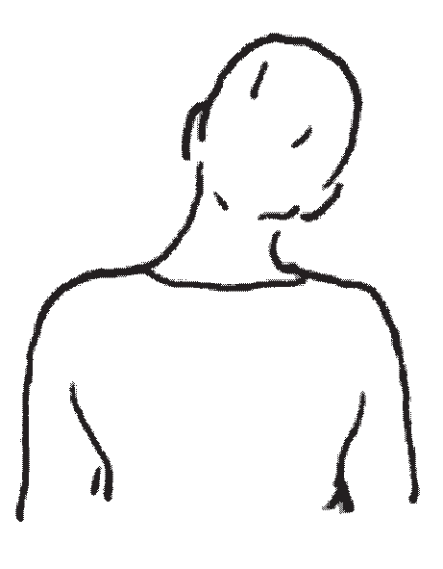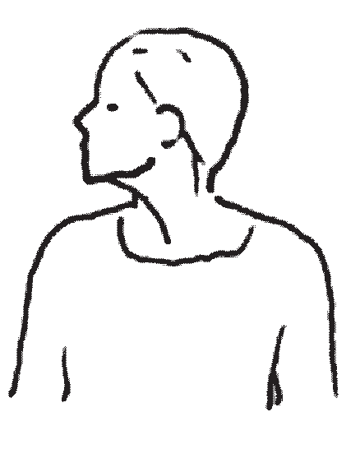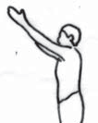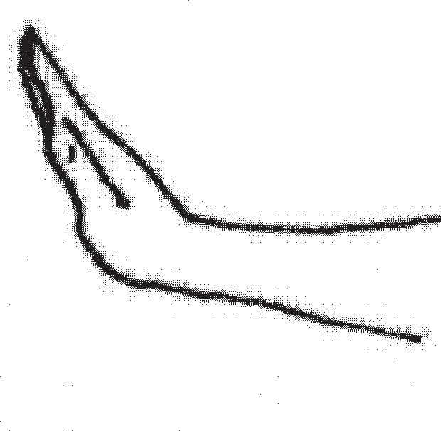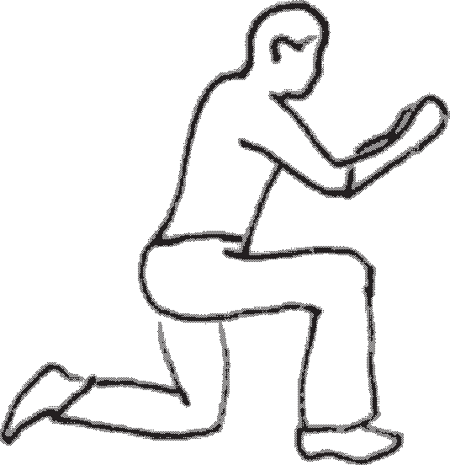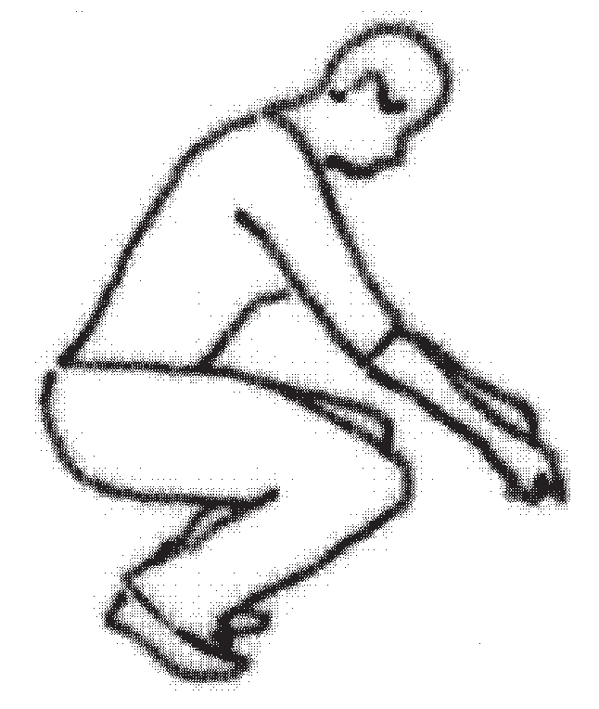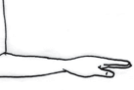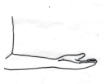

F P R T

**Tips for completing this section**

* Observe work and talk to workers to determine if any of the awkward/static postures are present
* If an awkward posture is identiﬁed, check the appropriate box beside its picture:
  + “F” if force is applied while in the awkward posture and the level of force is noted as a concern
  + “R” if same awkward posture must be performed repeatedly by the workers
  + 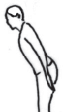“T” if the task must be performed for a long period of time without a change in posture/ activity

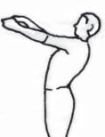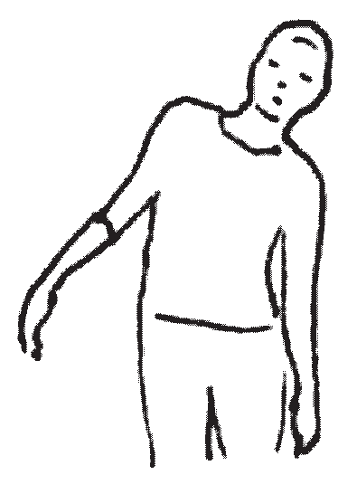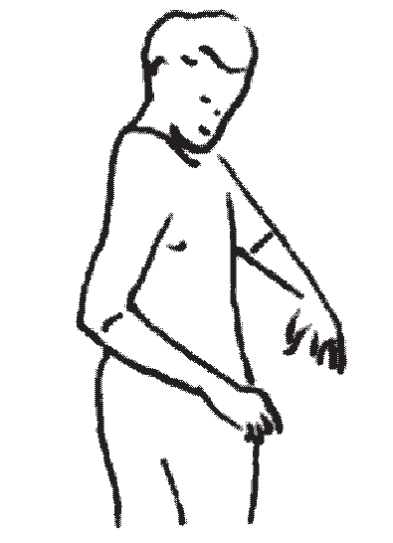

|  |  |  |  |  |  |  |  |  |  |  |  |  |  |  |  |  |
| --- | --- | --- | --- | --- | --- | --- | --- | --- | --- | --- | --- | --- | --- | --- | --- | --- |
| Job/Task Information | | | | | | | | | | | | | | | | |
| Job title or task: | | | | | | | | | | | | | | | | |
| Date completed: | | | | | | | | | | | | | | | | |
| Awkward/Static Postures | |  |  |  |  |  |  |  |  |  |  |  |  |  |  | Notes |
| **F R**  **T**  Back bent foward | **F R**  **T**  Bent backward | | | | |  | **F** | Bent to side | **R**  **T** |  | **F R**  **T**  Twisting | | | | |  |
| **F R**  **T**  Neck bent forward | **F R**  **T**  Neck bent backards | | | | | **F R**  **T**  Neck bent to side | | | | | **F R**  **T**  Neck rotated | | | | |  |
| **F R**  **T**  Hands or elbows above shoulders |  | **F** |  | Arms out to the side | **R**  **T** | **F R**  **T**  Wrist bent up or down | | | | | **F R**  **T**  Wrist bent to either side | | | | |  |
| **F R**  **T**  Kneeling |  |  | **F** | Squatting | **R**  **T** | **F** |  | Palm up |  | **R**  **T** | **F R**  **T**  Palm down | | | | |  |

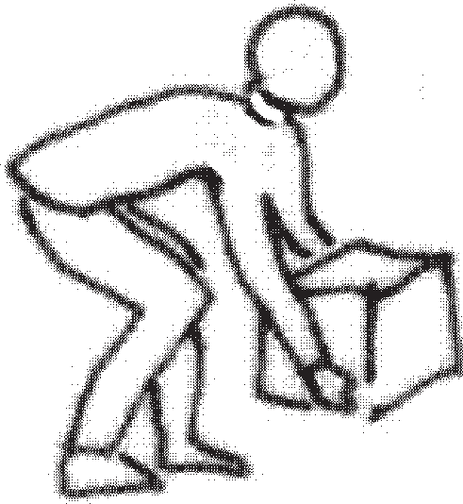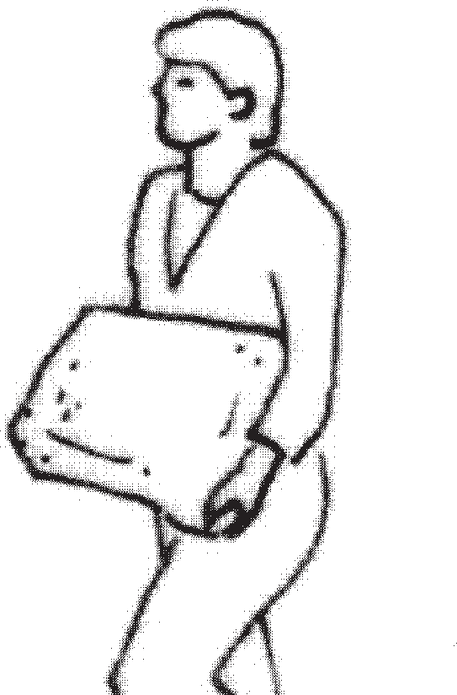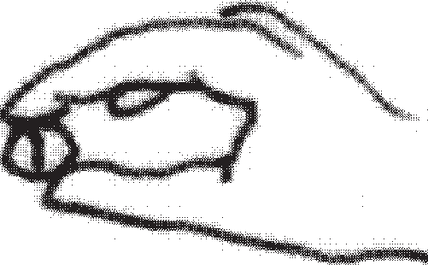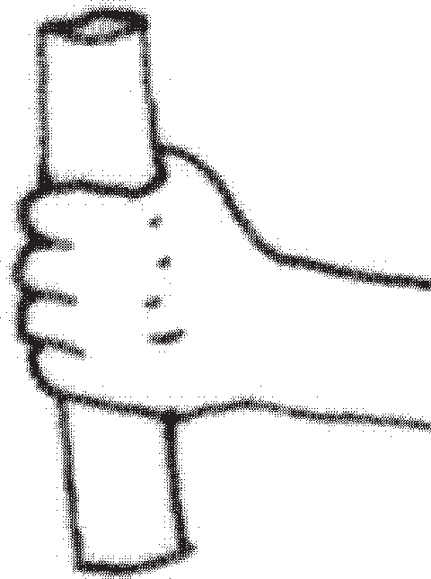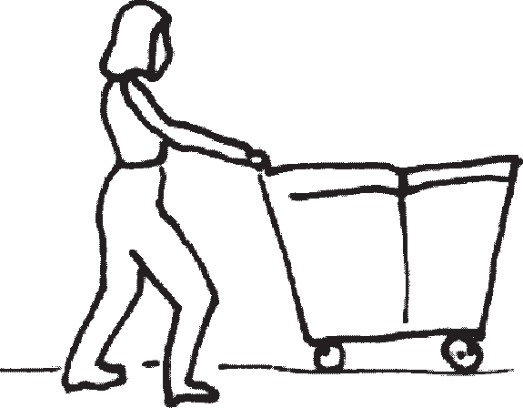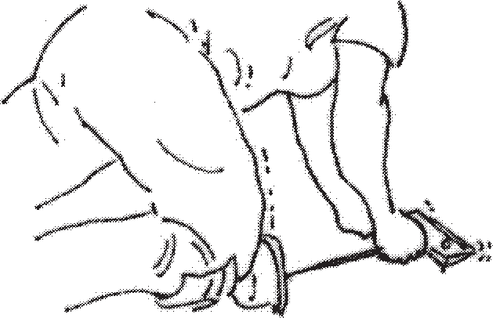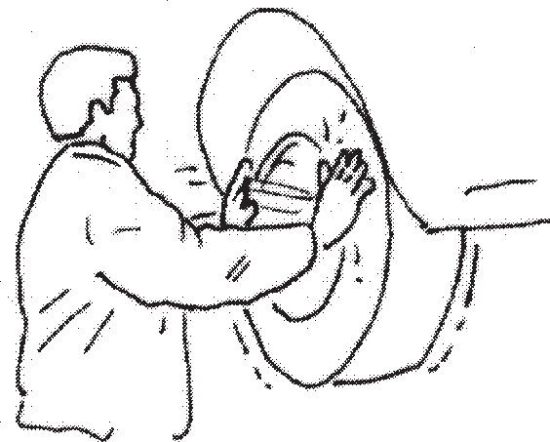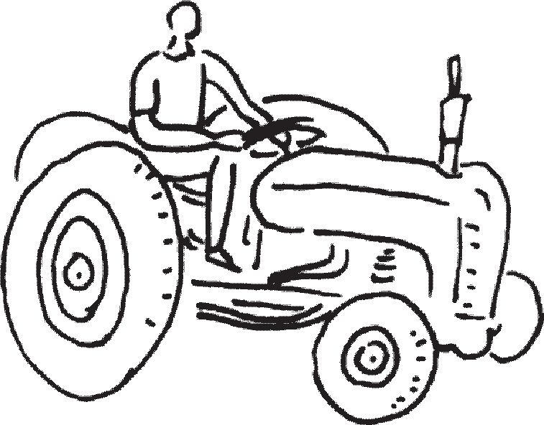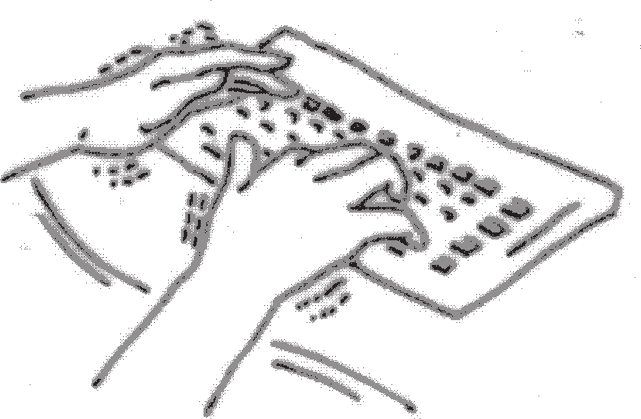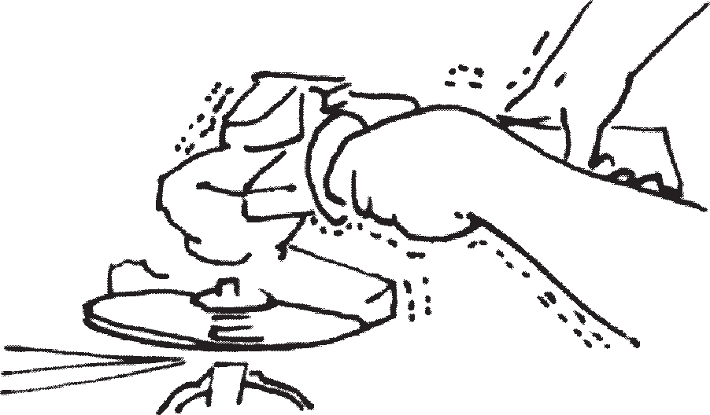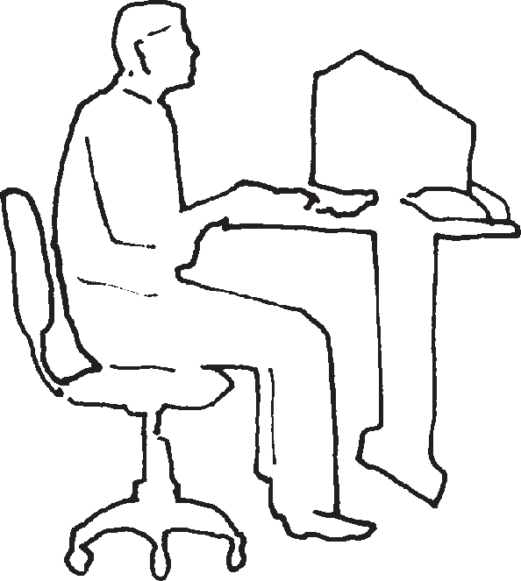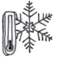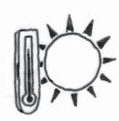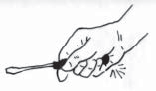

|  |  |  |  |  |  |  |  |  |  |  |  |  |
| --- | --- | --- | --- | --- | --- | --- | --- | --- | --- | --- | --- | --- |
| **Tips for Completing this Page**   * Observe work and talk to workers to determine if any of the activities/issues are present.   - If present, check the appropriate box beside its picture (as applicable): “F” if forces being exerted/weights handled are noted as a concern  “R” if the activity is performed repeatedly by the workers or workers are repeatedly exposed “P” if the workers adopt awkward postures during the activity or exposure  “T” if the activity is performed for a long time or workers are exposed for a long time | | | | | | | | | | | | |
| Manual Material Handling Notes | | | | | | | | | | | | |
| **F**  **P** | Lifting | **R**  **T** | **F R**  **P T**  Pushing/Pulling | | | **F R**  **P T**  Carrying | | | |  | | |
| Gripping | | | | | | | | | | | | |
| **F**  **P** | Pinch Grip | **R**  **T** | **F**  **P** | Grip | **R**  **T** |  | **F** | Contact stress | **R**  **T** |  | | |
| Other | | | | | | | | | | | | |
| **P** | Sitting | **T** | **P** | Standing | **T** | **F R**  **P T**  Keyboarding/Mousing | | | | **F**  **P** | Using knee or hand as a hammer | **R**  **T** |
| **F R**  **P T**  Hand-arm vibration | | | **F R**  **P T**  Whole-body vibration | | | **F** |  | Hot/Cold temperatures | | | **R**  **T** |  |
| Notes:  If the activity-related physical demands required vary from day to day, due to different products/services being produced or provided, ask workers if the activity being observed is more or less demanding than on a typical day.   * If less demanding, plan to come back when the demands are both more typical and, if appropriate, higher. * If more demanding, complete the hazard identification tool. It may be that MSD hazards are only a concern for certain products/services. You should also reuse the tool when the demands are more typical. * If typical, but there are times when the demands are higher, reuse the tool when the demands are higher, especially if there are no MSD hazards identified when observing typical demands. | | | | | | | | | | | | |