MSD Hazard Identification Tool: Computer workstation

Job/Task Information
Job title or task:
Date completed: |  |  | Completed by:
A. Chair
MSD HAZARDS |  | Is the hazard present? |  | CORRECTIVE OPTIONS  Potential steps to reduce or eliminate the risk associated with the MSD hazard.
 |  | Yes | No
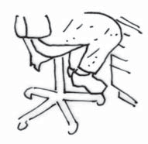 | 1. Feet cannot rest flat on floor | ■ | ■ | - Raise/lower chair to allow feet to rest comfortably flat on floor.  - Use footrest if keyboard/desk height requires an elevated chair.
 | 2. Unable to sit with thighs parallel to the floor, or with a slight downward angle from hips to knees | ■ | ■ | - Adjust chair height so that feet remain flat on floor or footrest but thighs are also parallel to floor.
 | 3. Front edge of seatpan presses into back of knee | ■ | ■ | - Choose a chair with 2-3 fingers width between front edge of chair and back of knees.  - Attach a removable back support cushion to existing backrest to shorten seat pan.  - Choose a chair with a gently curved front edge on seat pan.
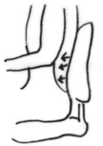 | 4. Chair lumbar support NOT supporting the small of the back (i.e. the curve of the lumbar spine) | ■ | ■ | - Raise/lower the back rest so the small of the back is in contact with the most outward curved areas of the back support.  - Place a rolled up towel or attach a removable back support cushion to existing back support.
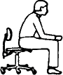 | 5. Space exists between spine and back rest | ■ | ■ | - Arrange workstation to allow proper back support. (i.e. position keyboard closer to user, bring monitor closer to user).  - Remove or lower arm rests which may prevent sitting back fully due to contact with front of desk or keyboard tray.  - Replace the seat pan if it’s too long and doesn’t allow for sitting back fully in chair.
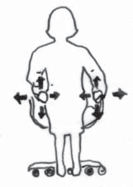 | 6. Armrests provide inadequate forearm support when keying or mousing. Hunched shoulders - armrests  too high; leaning to one side – armrests too low; elbows away from the body – armrests too wide | ■ | ■ | If armrests are too low/too high:  - Add padding to bring them up to a comfortable level.  - Only use the armrest during short pauses from typing.  - Replace with armrests that can be adjusted to the correct height.  If armrests are too wide:  - Adjust to bring them closer together.  - Replace seat pan on chair with a narrower one.  - Replace with width-adjustable armrests.
Notes:

B: Keyboard and mouse or other input device
MSD HAZARDS |  |  | Is the hazard present? |  | CORRECTIVE OPTIONS  Potential steps to reduce or eliminate the risk associated with the MSD hazard.
 |  |  | Yes | No
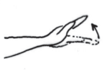 |  | 1. Wrist is not flat, forearms not parallel with floor or shoulders are tensed when using keyboard, mouse or other input device | ■ | ■ | - Adjust seat height so that keyboard and mouse sits just below elbow height.  - Raise or lower adjustable work surfaces in systems. furniture so that they are just below seated elbow height.  - Place keyboard and mouse on articulating keyboard tray and adjust tray height and tilt until wrists are working in neutral posture.  - Retract keyboard feet.  - Support arms on armrest when keying or mousing.
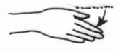 |  | 2. Wrist is deviated when using keyboard, mouse or input device. | ■ | ■ | - Ensure adequate space for input device.  - Use an appropriately sized keyboard (e.g. external keyboard if laptop is used regularly on desk).
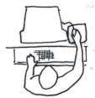 |  | 3. Reaching to side or front when using mouse or other input device (i.e. the elbow is away from side of body) | ■ | ■ | - Place mouse/input device beside keyboard at same height.  - Use a mouse bridge (i.e. a hard surface that is placed over number pad on keyboard).  - Ensure adequate space on either the desk top or a keyboard tray for input devices.
Notes:
C. Monitor and Workstation
MSD HAZARDS |  |  | Is the hazard present? |  | CORRECTIVE OPTIONS  Potential steps to reduce or eliminate the risk associated with the MSD hazard.
 |  |  | Yes | No
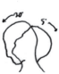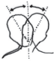  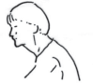 | 1. Head tilted up/down, repeatedly or for a long time, while working at desk |  | ■ | ■ | - Raise/lower monitor so that eyes are in line with top line of text. Monitor may need to be lowered for bifocal  wearers if they look at the monitor through the bottom of their lenses.  - If using a number of paper documents, use document holder that sits between the worker and the monitor.
 | 2. Head turned to the side, repeatedly or for a long time, when working |  | ■ | ■ | - Position monitor directly in front of user.  - Place documents on holder located in line with the computer.
 | 3. Neck tilted to the side, (i.e. holding phone between ear and shoulder) |  | ■ | ■ | - Maintain one hand on phone.  - Use a hands-free system (e.g. headphone).
 | 4. Head is not directly over spine (i.e. the head is forward and the chin is out) |  | ■ | ■ | - Arrange workstation to allow for proper posture, (e.g. sit back in chair, pull keyboard to user, change location/ height of monitor).
Notes:

C. Monitor and workstation (cont’d)
POTENTIAL MSD HAZARDS |  | Is the hazard present? |  |  |  | CORRECTIVE OPTIONS  Potential steps to reduce or eliminate the risk associated with the MSD hazard.
 |  | Yes |  | No
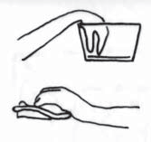 | 5. Hard/sharp objects press into skin (e.g. wrist, elbow or forearm resting on a hard edge/surface) | ■ |  | ■ |  | - Move keyboard/input devices to the edge of desktop to avoid resting hand/wrist on edge.  - Use a wrist rest for support during pauses in keying.  - Pad sharp edges on desktop with foam.  - Replace object with objects with rounded edges.  - Install keyboard tray with wrist rest for support during pauses in typing.
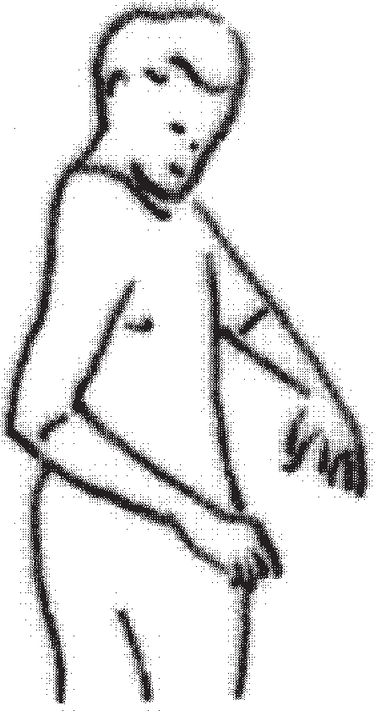 | 6. Twisting of torso (e.g. reaching behind or across the body) | ■ |  | ■ |  | - If user is right-handed, arrange accessories (except telephone) to the right of the computer.  - Locate telephone on the left in order to answer with the left hand and take notes with the right. Opposite set-up if left handed.  - Determine which accessories are used most frequently and locate them closest to the user.  - Encourage users to stand up when retrieving items behind them.
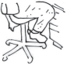 | 7. Inadequate clearance under desk for legs | ■ |  | ■ |  | - Remove materials underneath desk.  - Raise desktop surface for taller individuals, or chair may be lowered if knees remain at or slightly below the hips.  - Install keyboard tray to increase distance between monitor and desktop and provide more leg room.
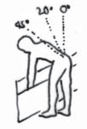 | 8. Repeated or prolonged trunk bending (e.g. filing documents) | ■ |  | ■ |  | - Where possible, perform filing on a desk surface, or other surface that allows for neutral back postures.
Notes:
D. Environmental
POTENTIAL MSD HAZARDS |  |  | Is the hazard present? |  |  |  | CORRECTIVE OPTIONS  Potential steps to reduce or eliminate the risk associated with the MSD hazard.
 |  |  | Yes |  | No
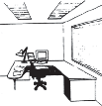 | 1. Too much/too little light |  | ■ |  | ■ |  | - Reduce the amount of light in work area, especially from ceiling-mounted light fixtures.  - Use low gloss, off-white colour on surfaces.  - Use appropriate task lighting.
 | 2. Glare on monitor |  | ■ |  | ■ |  | - Prevent source of glare from reaching monitor, (i.e. use opaque vertical blinds, use glare screens).  - Place monitor at right angles to windows.  - Use LCD monitors.
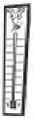 | 3. Temperature is less than 20°C or more than 24°C (dependent on individual comfort and season) |  | ■ |  | ■ |  | - Raise/lower temperature to individual comfort  - Wear more/less warm clothing.  - Use individual heaters where appropriate.
Notes:

Worksheet to prioritize jobs or tasks for simple risk assessment
VNP SHEQ Consulting
25
MUSCULOSKELETAL DISORDERS PREVENTION SERIES
| Part 3A: MSD Prevention Toolbox – Getting Started

TASK/JOB | MSDs REPORTED |  | WORKER DISCOMFORT/ OTHER CONCERNS |  | MSD HAZARD(S) IDENTIFIED |  | PRIORITY LEVEL
 | YES | NO | YES | NO | YES | NO

