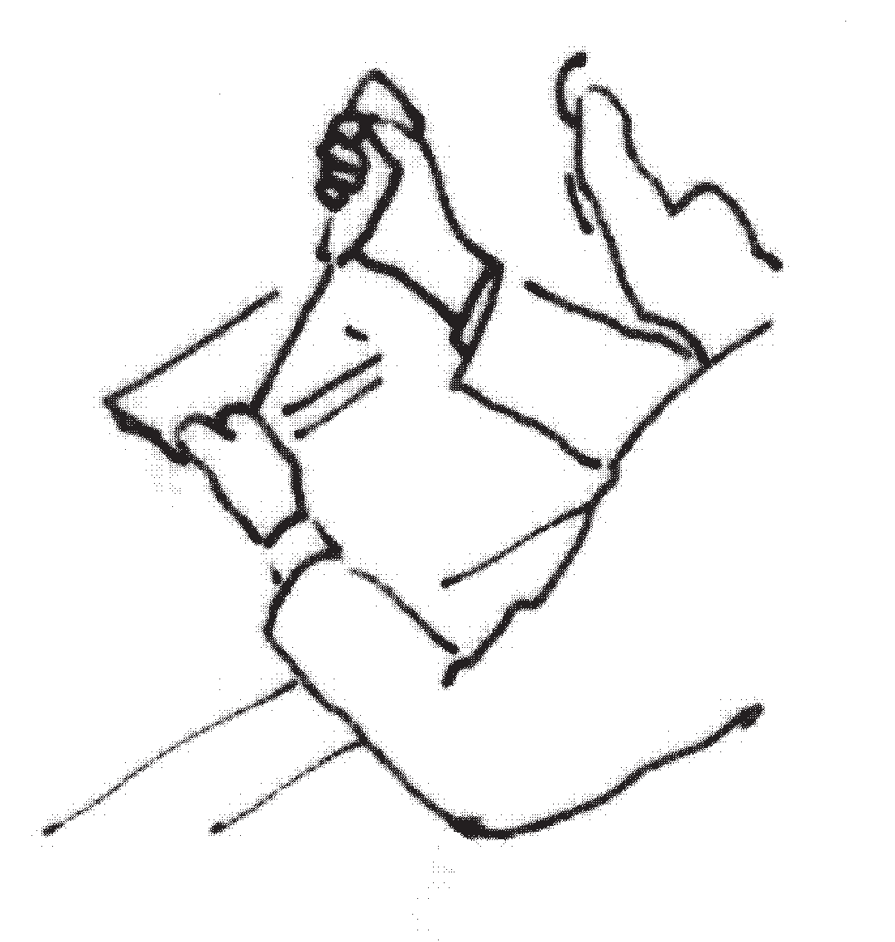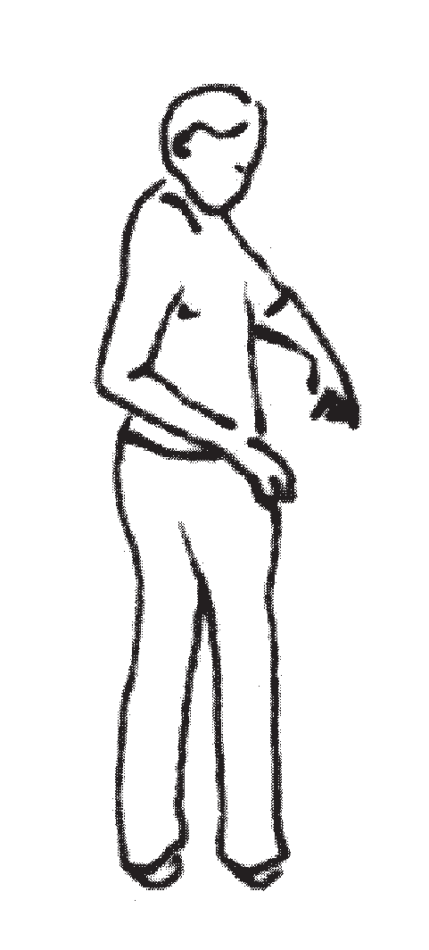MSD hazard summary sheet

|  |  |
| --- | --- |
| FORCE | **High force demands = increased MSD risk**  Force-related MSD hazards can be present when lifting, pushing, pulling, carrying, gripping, using tools. |
| POSTURE | **Awkward or static postures = increased MSD risk**  Posture-related MSD hazards can be present when bending, twisting, reaching, kneeling. |
| REPETITION | **Repetitive movements/actions = increased MSD risk**  Repetition-related MSD hazards can be present when doing the same thing over and over again, with little time for rest. |
| OTHERS | **Other MSD hazards that can increase MSD risk**  Include contact stress, hand-arm vibration, whole-body vibration, hammering with hand/knee, working in cold temperatures or hot environments.    Contact stress Hand-arm/whole-body vibration    Using hand/knee as hammer Cold and/or hot temperatures |

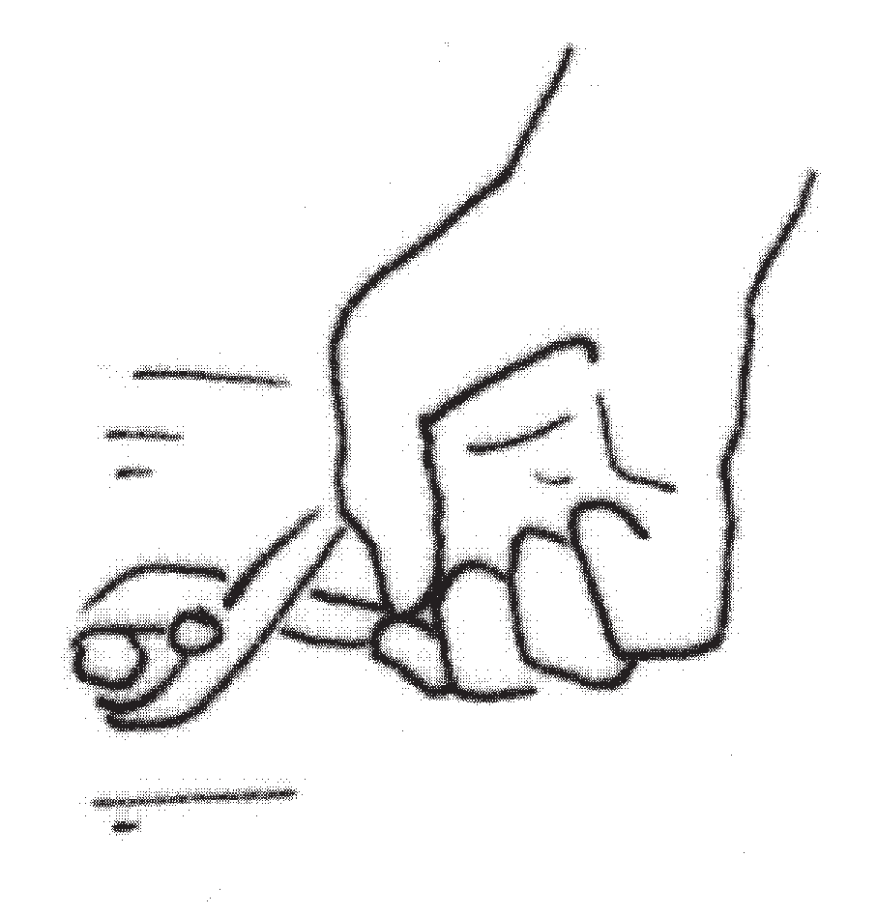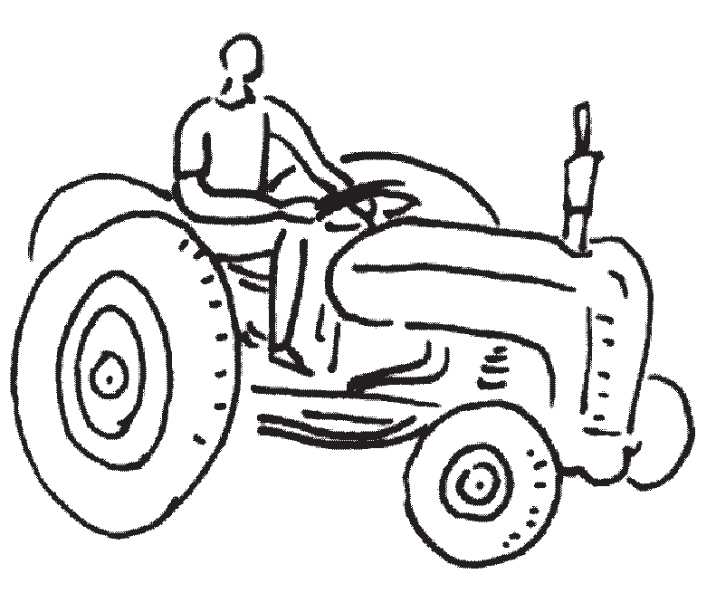

**6** MUSCULOSKELETAL DISORDERS PREVENTION SERIES | Part 3A: **MSD Prevention Toolbox –** Getting Started